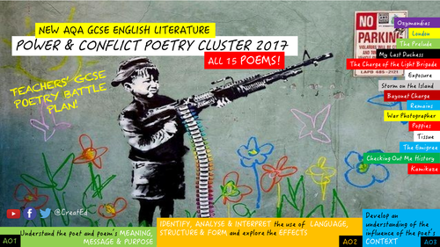
QUOTE GRID – CONFLICT POETRY
 | Gender | Nature | Anti-establishment | Futility of war | Dominant leader | Experience of battle | Celebrating heroism | Mental distress | Cultural identity | Violence | Patriotism | Loss/ absence | Memory
KAMIKAZE  1. But half way there  2. Flashing silver as their bellies/ swiveled towards the sun  3. he no longer existed | X | X |  |  |  |  |  | X | X |  |  | X
OZYMANDIAS  1. Two vast and trunkless legs of stone/ Stand in the desert  2. ‘My name is Ozymandias; king of kings.’  3. Round the decay/ Of that colossal wreck; boundless and bare; the lone and level sands stretch far away |  | X | X | X | X | X | X |  | X |  | X |  | X
REMAINS  1. probably armed, possibly not  2. sun-stunned, sand-smothered land  3. His bloody life in my bloody hands |  |  |  | X |  |  |  | X |  | X
CHARGE OF LIGHT BRIGADE  1. Cannon to right of them,/ Cannon to left of them,/ Cannon in front of them  2. All the world wonder’d  3. Left of six-hundred. |  |  | X |  |  | X | X |  |  |  | X

