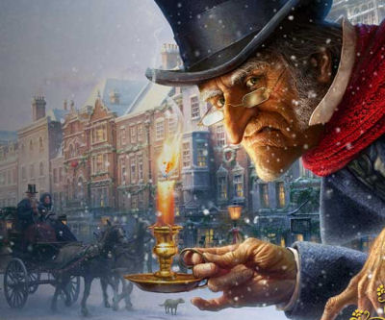
QUOTE GRID – A CHRISTMAS CAROL

 | Poverty/ Wealth/ Social Injustice/  Greed/ generosity | Time/ Space/ Memory | Light/ Dark | Youth/ Age | Christmas | Family & home/ Isolation | Redemption/ Transformation/ Forgiveness/ Blame | Supernatural | Scrooge | Fred | Cratchits | Tiny Tim | Fezziwig
Old Marley was as dead as a doornail |  | X |  | X |  | X | X | X | X
A squeezing, wrenching, grasping, scraping, clutching, covetous old sinner! | X |  |  | X |  | X | X |  | X |  | X |  | X
The fog came pouring in (& in stave five) no fog |  | X | X |  |  | X | X | X | X
“A merry Christmas” (Fred) and “Bah!… Humbug!” (Scrooge) | X |  |  | X | X | X | X |  | X | X | X
“buried with a stake of holly through his heart.” (Scrooge) | X |  |  |  | X | X | X | X | X | X |  |  | X
“decrease the surplus population.” (Scrooge) | X |  |  |  |  |  | X |  | X |  | X | X | X
wandering hither and thither in restless haste. | X | X |  | X |  | X | X | X | X
six to seven, and from seven to eight, and regularly up to twelve; then stopped.” |  | X |  | X |  |  |  | X | X
not so like a child as like an old man |  | X |  | X |  |  |  | X | X
“Would you so soon put out, with worldly hands, the light I give?” (Spirit of Christmas Past) |  | X | X |  | X |  | X | X | X
sobbed…. wept |  | X |  | X | X | X | X |  | X |  |  | X
“Home is like heaven!” (Little Fan) |  | X | X | X | X | X | X |  | X
Fezziwig | X | X |  |  | X | X | X |  | X |  | X |  | X
“a dowerless girl” (Belle) | X | X |  | X |  | X | X |  | X
“If these shadows remain unaltered by the Future, the child will die.” (Spirit of Christmas Present) | X | X | X | X |  |  | X | X | X |  | X | X
“Ignorance” “Want” (Spirit of Christmas Present” | X |  |  | X |  |  | X | X | X |  |  | X
a solemn Phantom, draped and hooded, coming like a mist |  |  | X |  |  |  | X | X | X
“we” (Bob Cratchit) |  | X |  |  |  | X | X |  | X | X | X | X
“Will you let me in, Fred?” (Scrooge) | X |  |  |  | X | X | X |  | X | X
God bless us, every one! | X |  |  | X | X | X | X |  | X |  | X | X | X

