English
Literature

Revision Pack

Revision Guide for AQA GCSE
English Literature

This document contains a sequence of activities, and guidance on how to complete these activities, which will build on the learning of the last two years and help you to achieve success in your examinations. There are a range of twenty-minute activities and you should aim to complete a minimum of three every week between now and your exam dates.

To improve your grades:
- Plan your revision and stick to the plan.
- Revise for twenty minutes at a time, somewhere quiet, where you won’t be disturbed or distracted.
- Revising doesn’t just mean reading; it means actively engage with, make notes on, produce evidence to show that you have completed a process.
- Revise with a pen and notepaper and store and save your revision in the same place so that you can look back at it and have a sense of achievement.
- Start revising now - don’t leave it until the last week.

Revision is the greatest single factor in exam success.
Exam Dates 2015

English Literature Paper 1 (Texts): Mon 18th May 2015
English Literature Paper 2 (Poetry): Fri 22nd May 2015
Exam Dates 2012

English Paper 1: 22nd May 2012
English Paper 2: 24th May 2012

Eight out of ten students, on getting their exam results, wished they’d revised more.

What are you expected to do in the examination?

English Literature

Paper 1

Section A: Modern Prose/Drama = Lord of the Flies / Martyn Pig / An Inspector Calls

Section B: Exploring Cultures Text = Of Mice and Men/ To Kill a Mockingbird

Paper 2

Section A: Poetry Cluster = Conflict / Character and Voice

English Literature

Paper 1

Section A: Modern Prose/Drama = Sunlight in the Grass short stories / Lord of the
Flies / Martyn Pig / An Inspector Calls

Section B: Exploring Cultures Text = Of Mice and Men

Paper 2

Section A: Poetry Cluster = Conflict / Character and Voice
Section B: Unseen Poetry

For English Literature you will be provided with a new and clean copy of the Anthology and all texts.

Revision is worth the effort - revision earns its own rewards.

Help yourself to be successful. Revise.

Revision Timetable

Remember to select at least three tasks each week. Write the number of the task you choose into the table so that you can check that you are not constantly repeating the same activities.

Week Commencing | English Literature | Parent Signature  Revision Checked
04/03/2015 | 1.  2.  3.  4.
11/03/2015 | 1.  2.  3.  4.
18/03/2015 | 1.  2.  3.  4.
25/03/2015  EASTER | 1.  2.  3.  4.
01/04/2015  EASTER | 1.  2.  3.  4.
08/04/2015 | 1.  2.  3.  4.

Week Commencing | English Literature | Parent Signature  Revision Checked
15/04/2015 | 1.  2.  3.  4.
22/04/2015 | 1.  2.  3.  4.
29/04/2015 | 1.  2.  3.  4.
06/05/2015 | 1.  2.  3.  4.
13/05/2015 | 1.  2.  3.  4.

English Literature: Suggested tasks

- Select two poems from your cluster and create a spidergram or picturegram describing the content, the themes, the structure and the significant and important phrases or language devices that best express the meaning of each poem.
- Read through the poems from your cluster and divide them into themes such as: death, family relationships, growing up, conflict, nature. Identify two ideas or phrases that particularly express the theme of each poem you have identified and, using a thesaurus, explain and explore that meaning, putting it into your own words. You might begin with this topic sentence: The poet is suggesting that…
- Spend 20 minutes on the BBC Bitesize website looking at some of the poems you have been studying and extend and develop your notes.
- Select two poems from your cluster and choose three phrases from each that best sum up for you the content and meaning of the poem: e.g.: from ‘Patrolling Barnegat’ Wild, wild the storm, and the sea high running suggests the feral and uncontrollable nature of the sea; the present tense suggests that it is always like this, and the use of the simple connective ‘and’ implies that it is expected and normal for the personified sea to be so untamed, like an animal. Remember, poetry can be described as ‘language working under pressure’: explore the meaning of the words, work out what that pressure is.
- Create a time-line of the key events from one of your novels/plays, naming the chapter or scene number in which each event is located. This will help you in your exam to find the evidence quickly when you need to.
- Choose a character from your novel or play to describe. Create a pin man drawing and then describe his or her character using the writer’s own words from the text. Describe them physically, how they say things, what they say, what the writer says about them, what other people say about them and what their impact is on the plot.
- Write a comparison between two characters in one of your novels/plays saying which one you prefer. Time yourself: allow five minutes for planning, and then, using the evidence taken from the pin men drawings you have completed, write the comparison in twenty minutes, remembering to structure your work using discourse markers such as: on the other hand, however, furthermore, in addition, in contrast and similarly.
- Consider the importance of setting in one of your novels/plays. Make notes on where and when it is set. What impact does that have on the story? What were the values of the time; was the location a contributing factor in the story? How do the characters react to their surroundings? How would the story be different if the novel were set elsewhere? Use a spidergram to record your findings and use quotations from the text to ensure that you can clearly describe the location and setting.
- Compile a list of the ideas or themes that are used in one of the novels/plays you are studying. Brainstorm some of the events that happen in one of the novels/plays under those headings. Identify the passages in the novel where you think this theme is explored and find how the writer describes these ideas. Find an exact quotation and explore it fully, what is the writer trying to say, and how does he or she say this? You should have four or five points under each theme; use different colours and chart it on a large size poster – stick it on the ceiling above your bed.
- From an essay plan, write a paragraph that explores how two poets express their meaning by using language. Select two phrases from each poem and really explore their connotations – what exactly is the poet trying to say? Structure your answer using connectives.
- Look at the spider diagrams you did from one of the novels/plays. Imagine you are in the exam and you are going to write an essay on any one of those themes. How quickly can you find the evidence in your book that you’ve written on your spider diagram? Time yourself, and practise. Finding four pieces of evidence to base your essay on will probably take you six and a half minutes first time. That’s too slow, so practise: you don’t want to be wasting time in the exam trying to find your way around the book.

- Look again at the themes of one of your novels/plays; they might be loneliness, dreams, cruelty, leadership, isolation, outsiders, revenge, fear. Take each word that is appropriate to your own novel and, using a thesaurus, explore the meaning of the word. What are the ideas behind it? Have you ever experienced, personally any of these? Is there a song, or a film, or a picture that explores the issues of any of the themes? Build up and secure your own understanding of each theme.
- Take significant phrases from a selection of poems you’ve enjoyed and write them onto strips of paper; stick them all over the walls and doors of your bedroom, kitchen (if you are allowed) and toilet. For this final week it will be really good for you to have these phrases in your mind, explaining to yourself and your family what they mean. It is through these phrases that the poet is communicating to you what he means – make sure you have considered all possible meanings to them; try explaining to your Granny, your baby sister, your dog.
- Work with a friend who is studying the same novel/play. Working in silence for 20 minutes, each one of you write a plan to answer the same essay question. Include your paragraph plan and the evidence you will use. Share your ideas, building on them and improving it. You will find practice essay question on Worksheet 3, 4, 5 or 6.
- Repeat number 14, but this time with a different question. When you’ve finished the plans, swap them, and write one of the paragraphs using your friend’s ideas. Now do you understand how important DETAILED planning is? In the exam, imagine your plan is going to be used by a total stranger so it must be absolutely clear: what are you going to say, how are you going to say it and what evidence will you use? A plan like this will ensure you are successful.
- Plan 3 poetry essays from the questions on Worksheet 1 or 2 depending what Cluster you are doing using a mind-map or another system your teacher has taught you. Remember you need ideas on language, structure and tone and you MUST compare the two poems. Your mind-map could look like the one on Worksheet 7 but in colour.
- Plan 2 of the essays from Worksheet 3, 4, 5 or 6 for any of your literature texts
- Using Worksheet 9, Do steps 1-5 for any poem you’ve not seen before. Either look on the following websites or, ideally, do a poem that a friend of yours is doing that you’re not. Then you can talk about the poem later.
  - http://www.poets.org/viewmedia.php/prmMID/20785
  - http://famouspoetsandpoems.com/thematic_poems/teen_poems.html
- Log onto GCSEPOD via www.tmac.uk.com/moodle Listen to any of the pods in English / Contemporary Poetry / Literacy Heritage Poetry / An Inspector Calls / Of Mice and Men / Lord of the Flies/ To Kill A Mockingbird (as long as you’ve studied the text/poetry with your teacher!! – If you are unsure please check with your teacher)
- Go to www.bbc.co.uk/schools/gcsebitesize/english and spend 20 minutes on any of the following sections Lord of the Flies / Of Mice and Men / To Kill A Mokcingbird / An Inspector Calls (as long as you’ve studied the text/poetry with your teacher!! – If you are unsure please check with your teacher)
- Turn the exam steps into pictures / actions. Only one picture/action for each step. See Worksheet 8
- Get someone to test you on the exam steps – once you’ve memorised them. See Worksheet 8

Worksheet 1:

Poetry Practice Questions

Character and Voice
Use the questions below to practise your exam response. Remember to start with a plan.

Foundation tier

- Compare the ways that poets present characters in ‘Brendon Gallacher’ and one other poem from ‘Character and voice’. Remember to compare:
- the characters in the poem
- how the characters are presented

- Compare your responses to ‘The Hunchback in the Park’ and one other poem from ‘Character and voice’. Say whether you like or dislike each of these poems and explain why. Remember to compare:
- the characters or ideas in the poem
- how the poems are written

Higher tier

- Compare how the poets develop a character’s voice in ‘Les Grands Seigneurs’ and one other poem from ‘Character and voice’.
- Compare how the poets present their characters in ‘Casehistory: Alison (head injury)’ and one other poem from ‘Character and voice’.
- Compare the presentation of characters in 'Medusa' and one other poem of your choice.
- Compare the presentation of women in 'Les Grands Seigneurs' and one other poem of your choice.
- Compare how strong emotions are presented in 'Medusa' and one other poem of your choice.
- Compare how injustice is presented in 'Checking Out Me History' and one other poem of your choice.

Worksheet 2:

Poetry Practice Questions

Conflict

Use the questions below to practise your exam response. Don’t forget to start with a plan.

Foundation tier

- Compare how war is shown in ‘The Falling Leaves’ and in one other poet from ‘Conflict’. Remember to compare
- the ideas about war in the poems
- how war is presented in the poems

- Compare how the poets’ attitude to conflict is shown in ‘Flag’ and in one other poem from ‘Conflict’. Remember to compare:
- the attitudes in the poem
- how the attitudes are presented

Higher tier

- Compare how poets use language to express their feelings about conflict in ‘Belfast Confetti’ and one other poem from ‘Conflict’.
- Compare how attitudes to war are presented in ‘next to of course god America i’ and one other poem from ‘Conflict’.
- Compare how poets use language to express their feelings about conflict in ‘Belfast Confetti’ and one other poem.
- Compare how attitudes to war are presented in ‘next to of course god America i’ and one other poem
- Compare how the results of war are shown in ‘Futility’ and one other poem.
- Compare how attitudes to conflict are shown in ‘Charge of the Light Brigade’ and one other poem.
- Compare how war is presented in ‘Charge of the Light Brigade’ and one other poem.
- Compare how attitudes to conflict are shown in ‘Flag’ and one other poem.
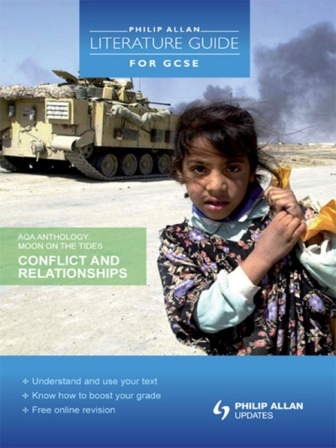

Worksheet 3:

An Inspector Calls- Practice Questions

- Inspector Goole merely functions as a mouthpiece for Priestley’s ideas. What do you think is the Inspector’s function in the play and how does Priestley present him?
- How does Priestley show the differences in attitudes between the generations in ‘An Inspector Calls’?
- How does J.B. Priestley portray his socialist views through ‘An Inspector Calls’?
- Discuss the presentation of power in ‘An Inspector Calls’.
- ‘An Inspector Calls’ is full of mystery and suspense. How is this created and maintained?
- Why is change so important in ‘An Inspector Calls’?
- Is ‘An Inspector Calls’ a classic ‘whodunit’?
- An Inspector Calls is full of lies and deceit. Write fully about the way Priestley exposes weakness and wickedness.
- In Act One of 'An Inspector Calls' how does J.B. Priestley use dramatic devices to convey his concerns and ideas to the members of the audience, as well as interest and involve them in his play?
- What is so important about the ending of ‘An Inspector Calls’?
- Is Mrs Birling more to blame for Eva’s death than any other character?

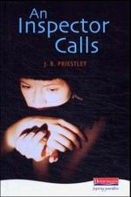

Worksheet 4 (Page 1 of 3):

Of Mice & Men- Practice Questions
(3 pages)

- Read the passage and then answer the questions which follow.

A few miles south of Soledad, the Salinas River drops in close to the hillside bank and runs deep and green. The water is warm too, for it has slipped twinkling over the yellow sands in the sunlight before reaching the narrow pool. On one side of the river the golden foothill slopes curve up to the strong and rocky Gabilan mountains, but on the valley side the water is lined with trees - willows fresh and green with every spring, carrying in their lower leaf junctures the debris of the winter's flooding; and sycamores with mottled, white, recumbent limbs and branches that arch over the pool. On the sandy bank under the trees the leaves lie deep and so crisp that a lizard makes a great skittering if he runs among them. Rabbits come out of the brush to sit on the sand in the evening, and the damp flats are covered with the night tracks of 'coons, and with the spread pads of dogs from the ranches, and with the split-wedge tracks of deer that come to drink in the dark. There is a path through the willows and among the sycamores, a path beaten hard by boys coming down from the ranches to swim in the deep pool, and beaten hard by tramps who come wearily down from the highway in the evening to jungle-up near water. In front of the low horizontal limb of a giant sycamore there is an ash pile made by many fires; the limb is worn smooth by men who have sat on it. Evening of a hot day started the little wind to moving among the leaves. The shade climbed up the hills toward the top. On the sand banks the rabbits sat as quietly as little gray, sculptured stones. And then from the direction of the state highway came the sound of footsteps on crisp sycamore leaves. The rabbits hurried noiselessly for cover. A stilted heron labored up into the air and pounded down river.

- How does Steinbeck use details in this passage to show what life was like in 1930’s America?
- How is nature imagery used in the novel as a whole?

- Read the passage and then answer the questions which follow.
A tall man stood in the doorway. He held a crushed Stetson hat under his arm while he combed his long, black, damp hair straight back. Like the others he wore blue jeans and a short denim jacket. When he had finished combing his hair he moved into the room, and he moved with a majesty only achieved by royalty and master craftsmen. He was a jerkline skinner, the prince of the ranch, capable of driving ten, sixteen, even twenty mules with a single line to the leaders. He was capable of killing a fly on the wheeler's butt with a bull whip without touching the mule. There was a gravity in his manner and a quiet so profound that all talk stopped when he spoke. His authority was so great that his word was taken on any subject, be it politics or love. This was Slim, the jerkline skinner. His hatchet face was ageless. He might have been thirty-five or fifty. His ear heard more than was said to him, and his slow speech had overtones not of thought, but of understanding beyond thought. His hands, large and lean, were as delicate in their action as those of a temple dancer. He smoothed out his crushed hat, creased it in the middle and put it on. He looked kindly at the two in the bunk house. "It's brighter'n a bitch outside, " he said gently. "Can't hardly see nothing in here. You the new guys?" "Just come, " said George. "Gonna buck barley?" "That's what the boss says. " Slim sat down on a box across the table from George. He studied the solitaire hand that was upside down to him. "Hope you get on my team, " he said. His voice was very gentle. "I gotta pair of punks on my team that don't know a barley bag from a blue ball. You guys ever bucked any barley?"

Worksheet 4 (Page 2 of 3):

- How do the details in this passage add to your understanding of Slim?
- How does Steinbeck use the character of Slim and other characters in the novel as a whole to convey ideas about power in America in the 1930s?

- Read the passage and then answer the questions which follow.
Got a kitchen, orchard, cherries, apples, peaches, 'cots, nuts, got a few berries. They's a place for alfalfa and plenty water to flood it. They's a pig pen-' "An' rabbits, George. " "No place for rabbits now, but I could easy build a few hutches and you could feed alfalfa to the rabbits. " "Damn right, I could, " said Lennie. "You God damn right I could. " George's hands stopped working with the cards. His voice was growing warmer. "An' we could have a few pigs. I could build a smoke house like the one gran'pa had, an' when we kill a pig we can smoke the bacon and the hams, and make sausage an' all like that. An' when the salmon run up river we could catch a hundred of 'em an' salt 'em down or smoke 'em. We could have them for breakfast. They ain't nothing so nice as smoked salmon. When the fruit come in we could can it-and tomatoes, they're easy to can. Ever' Sunday we'd kill a chicken or a rabbit. Maybe we'd have a cow or a goat, and the cream is so God damn thick you got to cut it with a knife and take it out with a spoon. " Lennie watched him with wide eyes, and old Candy watched him too. Lennie said softly, "We could live offa the fatta the lan'. " "Sure, " said George. "All kin's a vegetables in the garden, and if we want a little whisky we can sell a few eggs or something, or some milk. We'd jus' live there. We'd belong there. "Tell about the house, George, " Lennie begged. "Sure, we'd have a little house an' a room to ourself. Little fat iron stove, an' in the winter we'd keep a fire goin' in it. It ain't enough land so we'd have to work too hard. Maybe six, seven hours a day. We wouldn't have to buck no barley eleven hours a day. An' when we put in a crop, why, we'd be there to take the crop up. We'd know what come of our planting. " "An' rabbits, " Lennie said eagerly.

- How does Steinbeck use details in this passage to show the importance of dreams in 1930s America?
- What is the significance of dreams in the novel as a whole?

- Read the passage and then answer the questions which follow.
Crooks, the Negro stable buck, had his bunk in the harness room; a little shed that leaned off the wall of the barn. On one side of the little room there was a square four-paned window, and on the other, a narrow plank door leading into the barn. Crooks' bunk was a long box filled with straw, on which his blankets were flung. On the wall by the window there were pegs on which hung broken harness in process of being mended; strips of new leather; and under the window itself a little bench for leatherworking tools, curved knives and needles and balls of linen thread, and a small hand riveter. On pegs were also pieces of harness, a split collar with the horsehairstuffing sticking out, a broken hame, and a trace chain with its leather covering split. Crooks had his apple box over his bunk, and in it a range of medicine bottles, both for himself and for the horses. There were cans of saddle soap and a drippy can of tar with its paint brush sticking over the edge. And scattered about the floor were a number of personal possessions; for, being alone, Crooks could leave his things about, and being a stable buck and a cripple, he was more permanent than the other men, and he had accumulated more possessions than he could carry on his back. Crooks possessed several pairs of shoes, a pair of rubber boots, a big alarm clock and a single-barreled shotgun. And he had books, too; a tattered dictionary and a mauled copy of the California civil code for 1905. There were battered magazines and a few dirty books on a special shelf over his bunk. A pair of large gold-rimmed spectacles hung from a nail on the wall above his bed. This room was swept and fairly neat, for Crooks was a proud, aloof man. He kept his distance and demanded that other people keep theirs.

Worksheet 4 (Page 3 of 3):

- How does Steinbeck use details in this passage to create the sense of loneliness felt by the migrant workers during the economic depressions of the 1930s.
- How does loneliness impact the lives of all the characters throughout the novel?

- Read the passage and then answer the questions which follow.
Lennie's big fingers fell to stroking her hair. "Don't you muss it up, " she said. Lennie said, "Oh! That's nice, " and he stroked harder. "Oh, that's nice. " "Look out, now, you'll muss it. " And then she cried angrily, "You stop it now, you'll mess it all up. " She jerked her head sideways, and Lennie's fingers closed on her hair and hung on. "Let go, " she cried. "You let go!" Lennie was in a panic. His face was contorted. She screamed then, and Lennie's other hand closed over her mouth and nose. "Please don't, " he begged. "Oh! Please don't do that. George'll be mad. " She struggled violently under his hands. Her feet battered on the hay and she writhed to be free; and from under Lennie's hand came a muffled screaming. Lennie began to cry with fright. "Oh! Please don't do none of that, " he begged. "George gonna say I done a bad thing. He ain't gonna let me tend no rabbits. " He moved his hand a little and her hoarse cry came out. Then Lennie grew angry. "Now don't, " he said. "I don't want you to yell. You gonna get me in trouble jus' like George says you will. Now don't you do that. " And she continued to struggle, and her eyes were wild with terror. He shook her then, and he was angry with her. "Don't you go yellin', " he said, and he shook her; and her body flopped like a fish. And then she was still, for Lennie had broken her neck.

- How does Steinbeck create a sense of violence in this passage?
- What is the significance of violence in the novel as a whole?
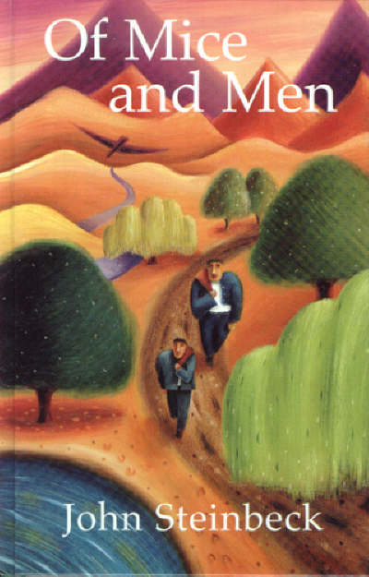
Worksheet 5:

Martyn Pig- Practice Questions

- “You told me once that badness is a relative thing – you said that something’s only wrong if you think it’s wrong. How ‘bad’ do you think Alex is and how does Brooks present her in the novel?

- “Home is home, I suppose. No matter how much you hate it, you still need it. You need whatever you’re used to. You need security.” How does Brooks show Martyn’s feelings about his home in the novel?

- Write about the importance of two of the following relationships in Martyn Pig. Martyn and his
father Martyn and Alex Martyn and Aunty Jean. How does Brooks present these relationships?

- The ending of Martyn Pig may come as a surprise to the reader. What do you find surprising [or not] about the ending, and how does Brooks prepare the reader for this ending in the rest of the novel?

- How do you respond to Aunty Jean in the novel Martyn Pig?
Write about:
- what you think about Aunty Jean from what she says and does
- what other characters say about her
- the methods the writer uses to present Aunty Jean.

- Do you think that Martyn Pig is an exciting novel?
Write about:
- what makes you think it is an exciting novel, or not
- the methods the writer uses to make you respond as you do

- How does the author present the character of ‘Billy Pig’ in the novel Martyn Pig ?
Write about:
- How is Billy described as a ‘father’?
- Who is more of a ‘father figure’?
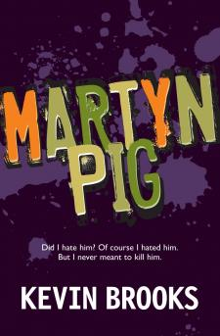
- Explain why.

Worksheet 6 (Page 1 of 3):

To Kill A Mockingbird- Practice Questions
(3 pages)

- Read the passage and then answer the questions below.
“The Radley Place jutted into a sharp curve beyond our house. Walking south, one faced its porch; the sidewalk turned and ran beside the lot. The house was low, was once white with a deep front porch and green shutters, but had long ago darkened to the colour of the slate-grey yard around it. Rain-rotted shingles drooped over the eaves of the verandah; oak trees kept the sun away. The remains of a picket drunkenly guarded the front yard – a ‘swept’ yard that was never swept – where johnson grass and rabbit-tobacco grew abundance.
Inside the house lived a malevolent phantom. People said he existed, but Jem and I had never seen him. People said he went out at night when the moon was down, and peeped in windows. When people’s azaleas froze in a cold snap, it was because he had breathed on them. Any stealthy small crimes committed in Maycomb were his work. Once the town was terrorized by a series of morbid nocturnal events: people’s chickens and household pets were found mutilated; although the culprit was Crazy Addie, who eventually drowned himself in Barker’s Eddy, people still looked at the Radley Place, unwilling to discard their initial suspicions. A Negro would not pass the Radley Place at night, he would cut across to the sidewalk sidewalk opposite and whistle as he walked. The Maycomb school grounds adjoined the back of the Radley lot; from the Radley chickenyard tall pecan trees shook their fruit into the schoolyard, but the nuts lay untouched by the children: Radley pecans would kill you. A baseball hit into the Radley yard was a lost ball and no questions asked.”

- How does the description of the Radley Place reveal character?
- What purpose does Boo Radley serve in the novel?

- Read the passage on the next page and then answer the questions below.

“The churchyard was brick-hard clay, as was the cemetery beside it. If someone died during a dry spell, the body was covered with chunks of ice until rain softened the earth. A few graves in the cemetery were marked with crumbling tombstones; newer ones were outlined with brightly coloured glass and broken Coca-Cola bottles. Lightning rods guarding some graves denoted dead who rested uneasily; stumps of burned-out candles stood at the heads of infant graves. It was a happy cemetery.
The warm bittersweet smell of clean Negro welcomed us as we entered the churchyard – Hearts of Love hairdressing mingled with asafoetida, snuff, Hoyt’s Cologne, Brown’s Mule, peppermint, and lilac talcum.
When they saw Jem and me with Calpurnia, the men stepped back and took off their hats; the women crossed their arms ay their waists, weekday gestures of respectful attention. They parted and made a small pathway to the church door for us. Calpurnia walked between Jem and me, responding to the greetings of her brightly clad neighbours.
‘What you up to, Miss Cal?’ said a voice behind us.
Calpurnia’s hands went to our shoulders and we stopped and looked around; standing in the path behind us was a tell Negro woman. Her weight was on one leg; she rested her left elbow in the curve of her hip, pointing at us with upturned palm. She was bullet-headed with strange almond-shaped eyes, straight nose, and an Indian-bow mouth. She seemed seven feet high.

Worksheet 6 (Page 2 of 3)
I felt Calpurnia’s hand dig into my shoulder. ‘What you want, Lula?’ She asked, in tones I had never heard her use. She spoke quietly, contemptuously.

‘I wants to know why you bringin’ white chillun to nigger church.’

- How does Lee show attitudes towards race in this passage?
- What is the significance of Calpurnia in the whole novel?

- Read the passage and then answer the question which follows.
“Tim Johnson reached the side-street that ran in front of the Radley Place, and what remained of his poor mind made him pause and seem to consider which road he should take. He made a few hesitant steps and stopped in front of the Radley gate; then he tried to turn around, but was having difficulty.
Atticus said, ‘He’s within range, Heck. You better get him now before he goes down the side street – Lord knows who’s around the corner. Go inside Cal.’
Calpurnia opened the screen door, latched it behind her, then unlatched and held on to the hook. She tried to block Jem and me with her body, but we looked out from beneath her arms.
‘Take him, Mr. Finch.’ Mr Tate handed the rifle to Atticus; Jem and I nearly fainted.
‘Don’t waste time, Heck,’ said Atticus. ‘Go on.’
‘Mr Finch, this is a one-shot job.’
Atticus shook his hed vehemently: ‘Don’t just stand there, Heck! He won’t wait all day for you –’
‘For God’s sake, Mr Finch, look where he is! Miss and you’ll go straight into the Radley house! I can’t shoot that well and you know it!’
‘I haven’t shot a gun in thirty years – ’
Mr Tate almost threw the rifle at Atticus. ‘I’d feel mighty comfortable if you did now,’ he said.
In a fog, Jem and I watched our father take the gun and walk out into the middle of the street. He walked quickly, but I thought he moved like an underwater swimmer; time had slowed to a nauseating crawl.
When Atticus raised his glasses Calpurnia murmured, ‘Sweet Jesus hlp him,’ and put her hands to her cheeks.
Atticus put his glasses to his forehead; they slipped down, and he dropped them in the street. In the silence, I heard them crack. Atticus rubbed his eyes and chin; we saw him blink hard.
In front of the Radley gate, Tim Johnson had made up what was left of his mind. He had finally turned himself around, to pursue his original course up our street. He made two steps forward, then stopped and raised his head. We saw his body go rigid.

- How does Lee create tension in this extract?
- How is the importance on family shown throughout the novel?

- Read the passage and then answer the questions below

“But Mr Tate said, ‘This court will come to order,’ in a voice that rang with authority, and the heads below us jerked up. Mr Tate left the room and returned with Tom Robinson. He steered Tom to his place beside Atticus, and stood there. Judge Taylor had roused himself to sudden alertness and was sitting up straight looking at the empty jury box.
What happened after that had a dreamlike quality: in a dream I saw the jury return moving like underwater swimmers, and Judge Taylor’s voice came from far away, and was tiny. I saw something only a lawyer’s child could be expected to see, could be expected to watch for, and it was like watching Atticus walk into the street, raise a rifle to his shoulder and pull the trigger, but watching all the time knowing that the gun was empty.
Worksheet 6 (Page 3 of 3):

A jury never looks at a defendant is has convicted, and when this jury came in, not one of them looked at Tom Robinson. The foreman handed a piece of paper to Mr Tate who handed it to the clerk who handed it to the judge ...
I shut my eyes. Judge Taylor was polling the jury: ‘Guilty ... guilty ... guilty ... guilty...’ I peeked at Jem: his hands were white from gripping the balcony rail, and his shoulders jerked as if each ‘guilty’ was a separate stab between them.
Judge Taylor was saying something. His gavel was in his fist, but he wasn’t using it. Dimly, I saw Atticus pushing papers from the table into his briefcase. He snapped it shut, went to the court reporter and said something, nodded to Mr Gilmer, and then went to Tom Robinson and whispered something to him. Atticus put his hand on Tom’s shoulder as he whispered. Atticus took his coat off the back of his chair and pulled it over his shoulder. Then he left the courtroom, but not by his usual exit. He must have wanted to go home the short way, because he walked quickly down the middle aisle towards the south exit. I followed the top of his head as he made his way to the door. He did not look up.
Someone was punching me, but I was reluctant to take my eyes from the people below us, and from the image of Atticus’s lonely walk down the aisle.
‘Miss Jean Louise?’
I looked around. They were standing. All around us and in the balcony on the opposite wall, the Negroes were getting to their feet. Reverend Sykes’s voice was as distant as Judge Taylor’s.
‘Miss Jean Louise, stand up. Your father’s passin’.’”

- How does Lee’s use of language present emotions in this passage?
- How does Lee use the trial of Tom Robinson to explore the themes of social and racial prejudice in the town of Maycomb?

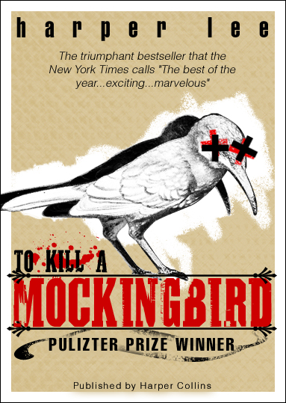

Worksheet 7:

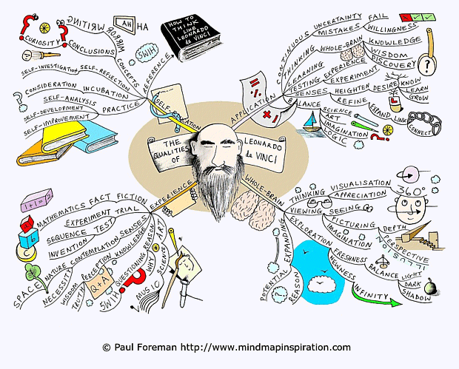
Mind-Map Example

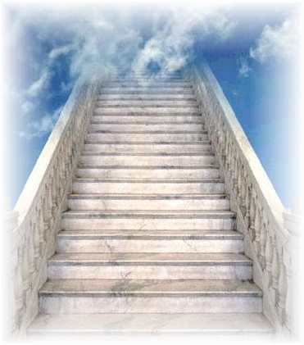
Worksheet 8:

ENGLISH LITERATURE EXAM STEPS

TEXTS EXAM

Part A – Lord of the Flies OR Martyn Pig OR Inspector Calls
Step 1 Find the page for the text you’ve studied
Step 2 Underline key words in the essay question
Step 3 Do a spider diagram of things you could say (need a minimum of 8 ideas)
Step 4 Write it (remember to PEE in every paragraph)
Step 5 Check it and change it

Part B – Of Mice & Men or To Kill a Mockingbird
Step 1 Find the page for the text you’ve studied
Step 2 Underline key words in the essay question
Step 3 Read and highlight interesting stuff in the extract
Step 3 Do a spider diagram of things you could say for part a and part b of the question (need a
minimum of 5 ideas on each spider diagram)
Step 4 Write it (remember to PEE in every paragraph)
Step 5 Check it and change it

POETRY EXAM

Part A - Conflict OR Character & Voice Poetry
Step 1 In section A, choose which question you are going to do for the poetry you have studied
(Conflict OR Character & Voice)
Step 2 Read and highlight key words in the exam question
Step 3 Do 2 spider diagrams for your two poems with things you can say about the poems (need 6
things on each spider diagram)
Step 4 Write your essay (remember in each paragraph to PEE on one poem, PEE on the other poem
then compare them)
Step 5 Check it and change it
Step 6 After 45 minutes stop writing

Part B - Unseen Poetry
Step 1 Read the poem 3 times, underlining anything interesting in the poem
Step 2 Underline key words in the exam question
Step 3 Do a spider diagram of things you can say about the poem (minimum 6 ideas)
Step 4 Write an essay on it (remember to PEE)
Step 5 Check it and change it

Worksheet 9:

Notes on how to tackle unseen poetry:

- Read the poem three times underlining/highlighting anything that seems interesting
- Label the words/phrases you’ve chosen with: ‘device = ?’ ‘effect = ?’
- Read the poem again
- Write down one sentence that sums up what the poet is saying (NOT what is happening)
- Plan it
    - Paragraph one – introduction (answer question & one sentence on poem)
    - Paragraph two – PEE on language
    - Paragraph three – PEE on structure
    - Paragraph four – conclusion (make a decision)
- Write it
- Check it & change it

